**EXPERIMENT NO.4**

AIM: To design the circuit of full subtractor.

IC USED: 7486(X-OR), 7408(AND), 7432(OR),7404(NOT).

THEORY: A full subtractor is a logical circuit that performs an subtraction operation on three binary digits. The full subtractor produces a difference and a borrow value which are both binary digits.

A Full adder circuit has three inputs A,B and C and two outputs – DIFF representing difference and BOR representing borrow.

**EXPERIMENT NO.4**

AIM: To design the circuit of full subtractor.

IC USED: 7486(X-OR), 7408(AND), 7432(OR),7404(NOT).

THEORY: A full subtractor is a logical circuit that performs an subtraction operation on three binary digits. The full subtractor produces a difference and a borrow value which are both binary digits.

A Full adder circuit has three inputs A,B and C and two outputs – DIFF representing difference and BOR representing borrow.

S = A xor B xor C

C = A’.B +C(A xnor B)

TRUTH TABLE:

| **A** | **B** | **C** | **DIFF** | **BOR** |
| --- | --- | --- | --- | --- |
| 0 | 0 | 0 | 0 | 0 |
| 0 | 0 | 1 | 1 | 1 |
| 0 | 1 | 0 | 1 | 1 |
| 0 | 1 | 1 | 0 | 1 |
| 1 | 0 | 0 | 1 | 0 |
| 1 | 0 | 1 | 0 | 0 |
| 1 | 1 | 0 | 0 | 0 |
| 1 | 1 | 1 | 1 | 1 |

SCHEMATIC DIAGRAM:

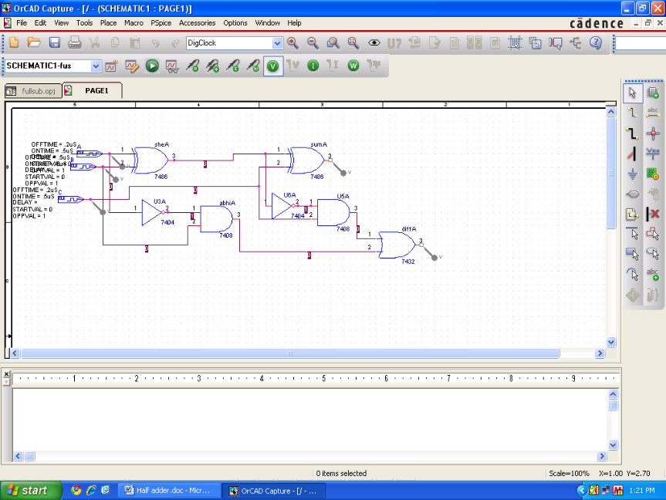

WAVEFORM:

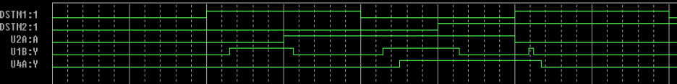

RESULT: The output waveform of full subtractor is verified.

S = A xor B xor C

C = A’.B +C(A xnor B)

TRUTH TABLE:

| **A** | **B** | **C** | **DIFF** | **BOR** |
| --- | --- | --- | --- | --- |
| 0 | 0 | 0 | 0 | 0 |
| 0 | 0 | 1 | 1 | 1 |
| 0 | 1 | 0 | 1 | 1 |
| 0 | 1 | 1 | 0 | 1 |
| 1 | 0 | 0 | 1 | 0 |
| 1 | 0 | 1 | 0 | 0 |
| 1 | 1 | 0 | 0 | 0 |
| 1 | 1 | 1 | 1 | 1 |

SCHEMATIC DIAGRAM:

WAVEFORM:

RESULT: The output waveform of full subtractor is verified.